
CHAPTER
Children and

Adolescents
I

Introduction

hildren and adolescents include individuals ages 2 through 18 a life stage characterized by transitions and the formation of dietary patterns. Suboptimal current intake patterns among children and adolescents and inadequate physical activity contribute to overweight and obesity in this life stage and risk of chronic disease (e.g., type 2 diabetes, cardiovascular disease) later in life. Changing this trajectory is crucial because dietary patterns established during this life stage tend to continue into adult years.
Healthy eating throughout this life stage involves the child or adolescent, families and caregivers, and institutions and settings where food is provided and consumed. Young children are fully reliant on others to provide their meals and snacks. As children transition to school-age and through adolescence, they are exposed to new food choices and begin to have more autonomy in the foods that are selected. New influences on eating behavior also emerge, such as peer pressure, which can create opportunities or challenges for establishing dietary patterns consistent with health and longevity. Adolescents acquire ever-greater independence in their food choices as they mature, with more time spent on their own with peers and more foods and beverages frequently consumed in social settings. Other factors that influence eating behavior include social supports, exposure to food marketing and promotion, and policies that determine community design.
Youth have diverse calorie and nutrient needs based on age and patterns of growth, development, and physical activity. Current intake data of young children show some components of a healthy dietary pattern that continue from the infant and toddler life stages. Before these components of a healthy dietary pattern are established, however, diet quality worsens through childhood and into adolescence and intake patterns drift further from recommendations in the Dietary Guidelines. Active community support is needed to help youth meet food group and nutrient goals with nutrientdense foods and beverages.

Childhood Overweight and Obesity
In the United States, 41 percent of children and adolescents are overweight or have obesity, and the prevalence is higher among Hispanic and non-Hispanic Black children and adolescents as compared to non-Hispanic Asians and Whites. Overweight and obesity put youth at high risk of serious health concerns. Youth with obesity are more likely to have immediate health risks, including high blood pressure, high cholesterol, and impaired glucose tolerance. They also are at increased risk of cardiovascular disease and type 2 diabetes beginning as soon as the teenage years and into adulthood. Psychological (e.g., anxiety, depression) and social concerns (e.g., bullying, stigma) also are more likely in children and adolescents with overweight or obesity.
The causes of childhood obesity are complex and interconnected. Behaviors (e.g., eating habits, level of physical activity, sedentary time) and the community in which a child or adolescent resides can influence risk of obesity. Genetics and the fetal environment also play a role in the development of obesity. However, many opportunities exist to help prevent or manage overweight and obesity as children transition through these life stages. The goal for children and adolescents with overweight or obesity is to reduce the rate of weight gain while allowing normal growth and development. This can primarily be done by emphasizing nutrient-dense food and beverage choices, minimizing calories from sources that do not contribute to a healthy dietary pattern, and encouraging regular

physical activity.
Healthy Dietary Patterns

Children and adolescents are encouraged to follow the recommendations on the types of foods and beverages that make up a healthy dietary pattern described in Chapter 1. Nutrition and Health Across the Lifespan: The Guidelines and Key Recommendations. Tables 3-1 to 3-3 display the Healthy U.S.-Style Dietary Pattern to illustrate the specific amounts and limits for food groups and other dietary components that make up healthy dietary patterns at the calorie levels appropriate for most children and adolescents across four age ranges: one table combining patterns relevant for ages 2 through 4 and ages 5 through 8, and single tables for ages 9 through 13 and for ages 14 through 18. Tables 3-1 to 3-3 also show the calories remaining for other uses about 10-15 percent of the total available—after meeting food group and nutrient goals through the selection of nutrient-dense foods and beverages.
Calorie needs generally increase throughout this life stage to support growth and development. Child and adolescent females generally have lower calorie needs than do males, with variations based on size and level of physical activity. During adolescence, the range of calorie intakes widens to support diverse growth trajectories. More information on the calorie estimates is provided in Tables 3-1 to 3-3 (see footnote 9) and in Appendix 2.
Estimated Calorie Needs.
The USDA Dietary Patterns, including the Healthy U.S.-Style Dietary Pattern, provide a framework to help children and adolescents follow a healthy dietary pattern and meet the Guidelines and their Key Recommendations. The USDA Foods Patterns can be customized based on dietary needs, personal preferences, and budgetary constraints. A variety of nutrient-dense foods and beverages can be selected across the food group and subgroups as part of an overall healthy dietary pattern. For more information about the USDA Food Patterns, see Chapter 1 and Appendix 3. USDA Dietary Patterns. For this age group, as for all the others, a figure comparing current intakes to recommendations is presented. See "Current Intakes" for more information.

Children Ages 2 Through 8
In early childhood (ages 2 through 4), females require about 1 ,000 to 1 ,400 calories per day and males require about 1 ,000 to 1 ,600 calories per day. With the transition to school-age (ages 5 through 8), females require about 1 ,200 to 1 ,800 calories per day and males require about 1 ,200 to 2,000 calories per day.

Physical Activity
Childhood and adolescence is a critical period for developing movement skills, learning healthy habits, and establishing a firm foundation for lifelong health and well-being. For youth, regular physical activity can improve bone health, cardiorespiratory and muscular fitness, and cognition (including academic achievement), and reduce the symptoms of depression.
Preschool-aged children should be active throughout the day to enhance growth and development. Adults caring for children during this age should encourage active play that includes a variety of activity types (light, moderate, or vigorous intensity) and aim for at least 3 hours per day.
School-aged children and adolescents need at least 60 minutes of moderateto-vigorous activity daily to attain the most health benefits from physical activity. Most activity can be aerobic, like walking, running, or anything that makes their heart beat faster. They also need muscle-strengthening and bone-strengthening activities that make their muscles and bones strong, like climbing on playground equipment, playing basketball, and jumping rope.


The U.S. Department of Health and Human Service's Physical Activity Guidelines for Americans and related Move Your Way^{s} resources have more information about the benefits of physical activity and tips on how to get started. Available at health.gov/paguidelines.
Nutrient-Dense Foods and Beverages Nutrient-dense foods and beverages provide vitamins, minerals, and other health promoting components and have little added sugars, saturated fat, and sodium. Vegetables, fruits, whole grains, seafood, eggs, beans, peas, and lentils, unsalted nuts and seeds, fat-free and low-fat dairy products, and lean meats and poultry—when prepared with no or little added sugars, saturated fat, and sodium are nutrientdense foods.
Table 3-1
Healthy U.S.-Style Dietary Pattern for Children Ages 2 Through 8, With Daily or Weekly Amounts From Food Groups, Subgroups, and Components
FOOD GROUP OR SUBGROUP^{b}  Vegetables (cup eq/day) | Daily Amount of Food From Each Group (Vegetable and protein foods subgroup amounts are per week)  Vegetable Subgroups in Weekly Amounts
 1,000 1,200 1,400 1,600 1,800 2,000
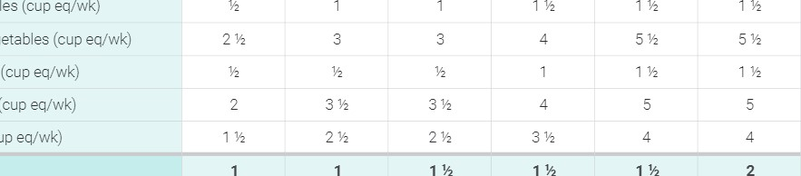
Dark-Green Vegetables (cup eq/wk)
Red and Orange Vegetables (cup eq/wk)
Beans, Peas, Lentils (cup eq/wk) Starchy Vegetables (cup eq/wk)
Other Vegetables (cup eq/wk)
Fruits (cup eq/day)
Grains (ounce eq/day) | 3 | 4 | 5 | 5 | 6 | 6
Whole Grains (ounce eq/day)
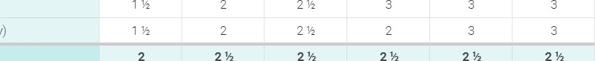
Refined Grains (ounce eq/day)
2%
2%
Dairy (cup eq/day)
Protein Foods (ounce eq/day) | 2 | 3 4 5 5  Protein Foods Subgroups in Weekly Amounts | 5%
Meats, Poultry, Eggs (ounce eq/wk) | 10 | 14 | 19 | 23 | 23 | 26
Seafood (ounce eq/wk) ^{C} | 2-3d | 4 | 6 | 8 | 8 | 8
Nuts, Seeds, Soy Products (ounce eq/wk) | 2 | 2 | 3 | 4 | 4 | 5
Oils (grams/day) | 15 | 17 | 17 | 22 | 22 | 24
Limit on Calories for Other Uses (kcal/day)^{e}  Limit on Calories for Other Uses (%/day) | 130 | 80  7% | 90  6% | 150 | 190 | 280

- Calorie level ranges: Ages 2 through 4, Females: 1 POO-I ,400 calories; Males: 1,000-1 ,600 calories. Ages 5 through 8, Females: 1 ,200-1 ,800 calories; Males: 1 calories. Energy levels are calculated based on reference height (median) and reference weight (healthy) corresponding with a healthy body mass index (BMI). Calorie needs vary based on many factors. The DRI Calculator for Healthcare Professionals, available at nal.usda.gov/fnic/dri-calculator, can be used to estimate calorie needs based on age, sex, height, weight, and activity level
- Definitions for each food group and subgroup and quantity (i.e., cup or ounce equivalents) are provided in Chapter 1 and are compiled in Appendix 3
- The LIS. Food and Drug Administration (FDA) and the U.S. Environmental Protection Agency (EPA) provide joint advice regarding seafood consumption to limit methylmercury exposure for children. Depending on body weight, some children should choose seafood lowest in methylmercury or eat less seafood than the amounts in the Healthy US-Style Dietary Pattern. More information is available on the FDA and EPA websites at FDA. gov/fishadvice and EPA.gov/fishadvice.
d
If consuming up to 2 ounces of seafood per week, children should only be fed cooked varieties from the "Best Choices" list in the FDA/ EPA joint "Advice About Eating Fish," available at FDA.gov/fishadvice and EPA.gov/fishadvice. If consuming up to 3 ounces of seafood per week, children should only be fed cooked varieties from the "Best Choices" list that contain even lower methylmercury: flatfish (e.g., flounder), salmon, tilapia, shrimp, catfish, crab, trout, haddock, oysters, sardines, squid, pollock„ anchovies, crawfish, mullet, scallops, whiting, clams, shad, and Atlantic mackerel If consuming up to 3 ounces of seafood per week, many commonly consumed varieties of seafood should be avoided because they cannot be consumed at 3 ounces per week by children without the potential of exceeding safe methylmercury limits; examples that should not be consumed include: canned light tuna or white (albacore) tuna, cod, perch, black sea bass. For a complete list please see: FDA.gov/fishadvice and EPA.gov/fishadvice_
^{e} Foods are assumed to be in nutrient-dense forms; lean or low-fat; and prepared with minimal added sugars, refined starches, saturated fat, or sodium. If all food choices to meet food group recommendations are in nutrient-dense forms, a small number of calories remain within the overall limit of the pattern (i.e., limit on calories for other uses). The number of calories depends on the total calorie level of the pattern and the amounts of food from each food group required to meet nutritional goals. Calories up to the specified limit can be used for added sugars and/or saturated fat, or to eat more than the recommended amount of food in a food group.
NOTE: The total dietary pattern should not exceed Dietary Guidelines limits for added sugars and saturated fat; be within the Acceptable Macronutrient Distribution Ranges for protein, carbohydrate, and total fats; and stay within calorie limits. Values are rounded. See Appendix 3 for all calorie levels of the pattern.

Figures 3-2 to 3-9 highlight the dietary intakes of children and adolescents, including the Healthy Eating Index-2015 score, which is an overall measure of how intakes align with the Dietary Guidelines, as well as information on the components of a healthy diet specifically, the food groups. Figures 3-1, 3-3, 3-5, and 3-7 display the average intakes of the food groups compared to the range of recommended intakes at the calorie levels most relevant to males and females in these age groups. Additionally, the percent of children and adolescents exceeding the recommended limits for added sugars, saturated fat, and sodium are shown, along with average intakes of these components. Average intakes compared to recommended intake ranges of the subgroups for grains are represented in daily amounts; subgroups for vegetables and protein foods are represented in weekly amounts (see Figures 3-2, 3-4, 3-6, and 3-8).
Current intakes show that from an early age, dietary patterns are not aligned with the Dietary Guidelines. The Healthy Eating Index score of 61 out of 100 for children ages 2 through 4 indicates that overall diet

Figure 3-1
quality is poor. Notably, HEI Scores decline throughout childhood and adolescence, with scores for adolescents approximately 10 points lower than those for young children (Figure 3-1).
Healthy Eating Index Scores Across Childhood and Adolescence
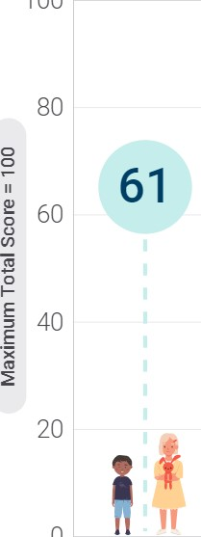

100
0
55
52 51
Ages 2-4 Ages 5-8 Ages 9-13 Ages 14-18
Data Source: Analysis of What We Eat in America, NHANES 2015-2016, ages 2 through 18, day 1 dietary intake, weighted.
Among children ages 2 through 4, consumption of total fruit is generally adequate for about 60 percent of children. Compared to other age groups, a higher percentage of young children also have intakes of total vegetables at or above recommended levels. The difference between recommended and actual intakes of total fruit and total vegetables emerges and expands as children age. By late adolescence, average fruit and vegetable consumption is about half of the recommended range of intake. Throughout youth, starchy vegetables (e.g., white potatoes, corn)—often in forms that are fried or prepared with additions such as butter and salt—are more frequently consumed than the red and orange; dark green; or beans, peas, and lentils vegetable subgroups. For fruit, about 70 percent of intake comes from whole forms fresh, canned, frozen, or dried—and 100% juice, which are often nutrient-dense forms. Some fruit is consumed through sources that are not nutrient-dense; for example, fruit as part of a baked dessert or juice drink.
The amount of dairy foods consumed by children and adolescents is relatively stable across age groups. Beginning at age 9 the amount of dairy foods in a healthy dietary pattern increases from 2 h to 3 cup equivalents per day to support an increase in calcium intake that is needed during these life stages. As a result, average intake of dairy foods is close to or at recommended levels for children younger than age 9 while consumption among adolescents is typically below recommended intake levels.

Although the gaps between recommended and current intakes widen throughout these life stages for some dietary components, others, principally whole grains and seafood, are infrequently consumed by any youth. Whole grains are consumed below recommended levels even by young children. As the difference between recommended and current intakes widens across age groups, the types of refined and whole-grain foods consumed remains consistent. Mixed dishes, such as pizza, pasta, sandwiches, burgers, and tacos, contribute about 50 percent of total grains intake, and snacks and sweets, such as chips, crackers, and cookies, about 20 percent. Breakfast cereals and bars, including ready to-eat and cooked varieties, are the top contributor to whole-grains intake during these life stages. Despite the underconsumption of whole grains, intakes of
total grains trend toward overconsumption due to the contribution of refined grains.
Total protein intake generally meets targets except for adolescent females ages 14 through 18. Youth typically meet or exceed recommendations for meats, poultry, and eggs. Seafood, a protein subgroup that can support intakes of beneficial fatty acids, is consumed at levels far below the lower end of the recommended intakes range. When seafood is consumed, it is typically as part of a mixed dish rather than as an individual food item.
Children and adolescents can improve intake patterns by maintaining the components of a healthy diet that are evident in early childhood, particularly total fruit and dairy foods, while increasing consumption of food groups that are underconsumed across all age groups, specifically total vegetables and vegetable subgroups, whole grains, and seafood. Reducing intakes of added sugars, saturated fat, and sodium—components of a dietary pattern that are often consumed above recommended limits beginning at an early age also will support youth in achieving a healthy dietary pattern, particularly when considering the very limited amount of calories available outside of those needed for meeting food group and nutrient goals.
Figure 3-2

Current Intakes: Ages 2 Through 4
Average Daily Food Group Intakes Compared to
Recommended Intake Ranges
Recommended Intake Ranges Average Intakes
6
Healthy Eating Index Score
(on a scale of 0-100)

5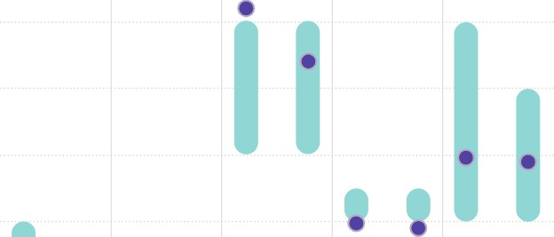
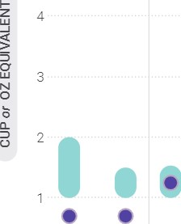
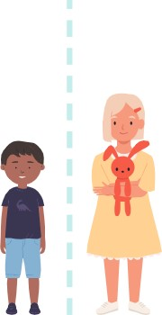
Total Total Total Total Total Vegetables Fruits Grains Dairy Protein Foods cup eq/day cup eq/day oz eq/day cup eg/day oz eq/day
FOOD GROUPS
Percent Exceeding Limits of Added Sugars, Saturated Fat, and Sodium |  | Exceeding Limit | Within Recommended Limit
Added Sugars | Saturated Fat |  | Sodium
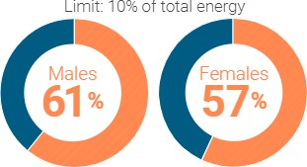
of total energy Limit: of total energy Limit: 1,200

oo oo
Average Intakes | Average Intakes  Females | Average Intakes
173 kcal 158 kcal | 191 kcal 177 kcal | 2,274 mg 2,061 mg
*NOTE: Children ages 2 through 3 should reduce sodium intake if above 1200 mg/d and those age 4 should reduce intake if above 1 ,500 mg/d.
Data Sources: Average Intakes and HEI-2075 Scores: Analysis of What We Eat in America, NHANES 201 5-2016, day 1 dietary intake data, weighted. Recommended Intake Ranges Healthy U.S.-Style Dietary Patterns (see Appendix'). Percent Exceeding Limits What We Eat in America, NHANES 2013-2016, 2 days dietary intake data, weighted.

Figure 3-3
Average Intakes of Subgroups Compared to Recommended
Intake Ranges: Ages 2 Through 4
Recommended Intake Ranges Average Intakes


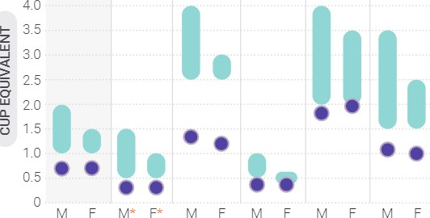
Vegetables
4.5
Total Dark- Red & Beans, Starchy Other Vegetables Green Orange Peas, cup eq/day Lentils cup eq/week

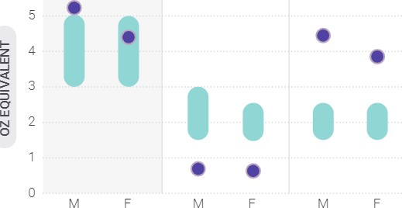
Grains
Total Whole Grains Refined Grains
Grains
- oz eq/day

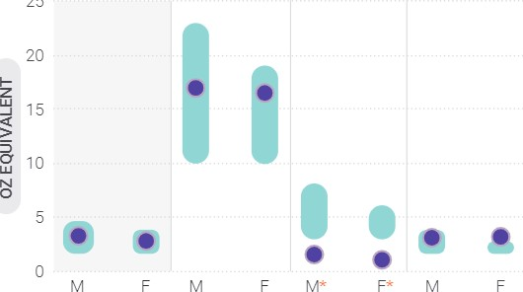
Protein Foods
25
Total Meats, Poultry, Seafood Nuts, Seeds,
Protein Foods Eggs Soy Products oz eg/day oz eq/week
*NOTE: Estimates may be less precise than others due to small sample size and/or large relative standard error.
Data Sources: Average Intakes: Analysis of What We Eat in America, NHANES 2015-2016, day 1 dietary intake data, weighted. Recommended Intake Ranges:
Healthy U.S.-Style Dietary Patterns (see Appendix 3
Figure 3-4

Current Intakes: Ages 5 Through 8
Average Daily Food Group Intakes Compared to
Recommended Intake Ranges
Recommended Intake Ranges Average Intakes Healthy Eating Index Score
(on a scale of 0-100)
8
7
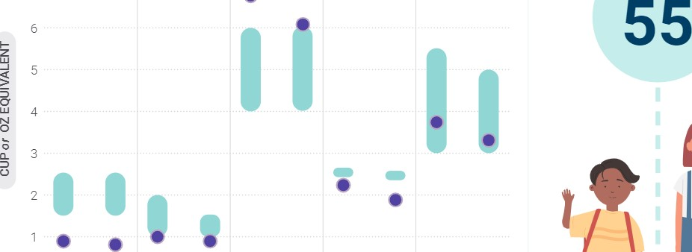

Total | Total | Total
Vegetables | Fruits | Grains
cup eg/day | cup eq/day | oz eq/day
FOOD GROUPS
Percent Exceeding Limits of Added Sugars,
Saturated Fat, and Sodium

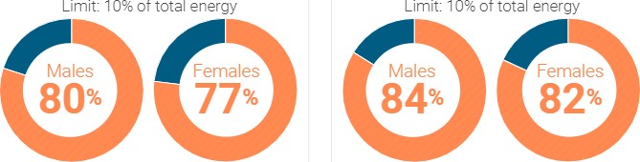
Added Sugars of total energy
Average Intakes
Females

Total Total
Dairy Protein Foods cup eg/day oz eg/day
Exceeding Limit Within Recommended Limit
Saturated Fat Sodium of total energy Limit: 1,500 mg

oo
Average Intakes Average Intakes
Females

266 kcal 238 kcal 218 kcal 195 kcal 2,785 mg 2,525 mg
Data Sources: Average Intakes and HEI-207 5 Scores Analysis of What We Eat in America, NHANES 2015-2016, day 1 dietary intake data, weighted. Recommended Intake Ranges: Healthy U.S.-Style Dietary Patterns (see Appendix 9). Percent Exceeding Limits What We Eat in America, NHANES 2013-2016, 2 days dietary intake data, weighted.
Figure 3-5
Average Intakes of Subgroups Compared to
Recommended Intake Ranges: Ages 5 Through 8 Recommended Intake Ranges Average Intakes


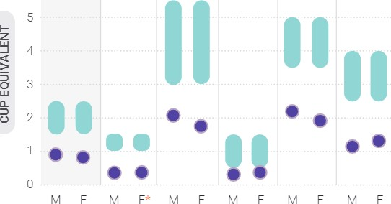
Vegetables
Total Dark- Red & Beans, Starchy Other Vegetables Green Orange peas, cup eq/day Lentils cup eq/week
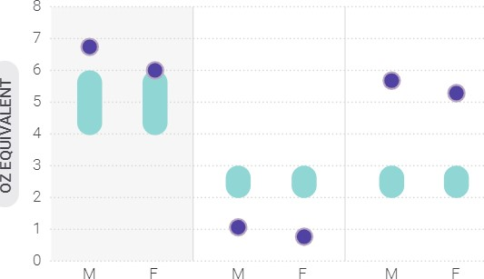
Grains 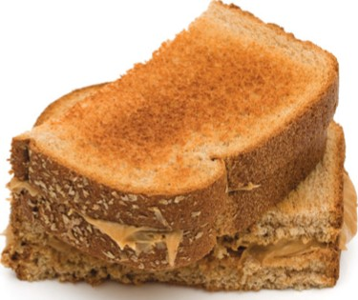

Total Whole Grains Refined Grains
Grains oz eq/day
Protein Foods
30

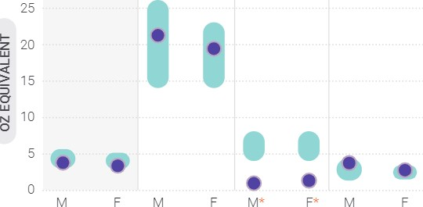
Total Meats, Poultry, Seafood Nuts, Seeds,
Protein Foods Eggs Soy Products oz eq/day oz eq/week
*NOTE: Estimates may be less precise than others due to small sample size and/or large relative standard error.
Data Sources: Average Intake: Analysis of What We Eat in America, NHANES
2015-2016, day 1 dietary intake data, weighted. Recommended Intake Ranges:
Healthy U.S.-Style Dietary Patterns (see Appendix.)

Children and Adolescents Ages 9 Through 13
In the late childhood and early adolescence stage, females require about 1 ,400 to 2,200 calories per day and males require about 1,600 to 2,600 calories per day.
Table 3-2
Healthy U.S.-Style Dietary Pattern for Children and Adolescents Ages 9 Through 13, With Daily or Weekly Amounts From Food Groups, Subgroups, and Components
2,200 | 2,400 | 2,600
1,400 1,600 1,800 2,000
FOOD GROUP OR SUBGROUP^{b} | Daily Amount of Food From Each Group  (Vegetable and protein foods subgroup amounts are per week)
Vegetables (cup eq/day) | 2 2% 3 3  Vegetable Subgroups in Weekly Amounts | 3%
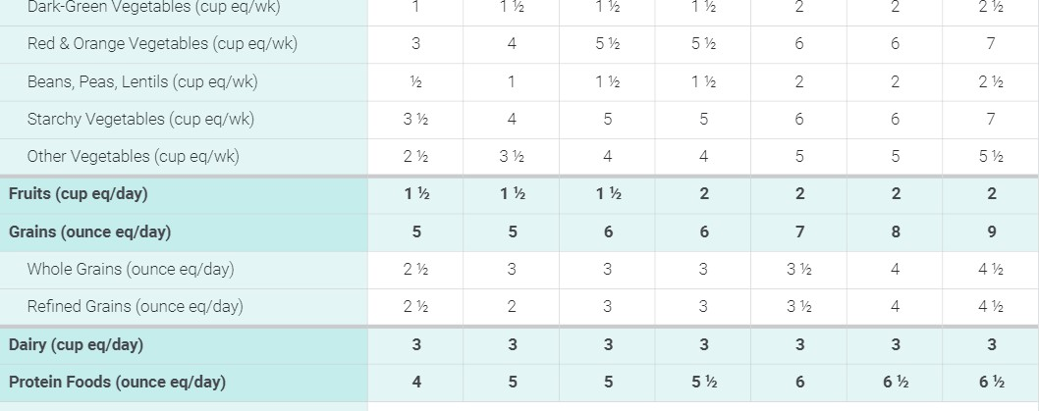
2 2
4 6 6 7
2 2
4 5 5 6 6 7
4 4 5 5
3 1/2 4
2 3 3 3 1/2 4
 |  |  | Protein Foods Subgroups in Weekly Amounts
Meats, Poultry, Eggs (ounce eq/wk) |  | 23 | 23 26 28 | 31 | 31
Seafood (ounce eq/wk) ^{C} | 6 | 8 | 8 8 | 10 | 10
Nuts, Seeds, Soy Products (ounce eq/wk) | 3 | 4 | 4 5 5 | 5 | 5
17 | 22 | 24 | 27 | 29 | 31 | 34
Oils (grams/day)
Limit on Calories for Other Uses (kcal/day)^{d} 50 | 100 | 140 240 250 320 350
Limit on Calories for Other Uses (%/day) 4% | 6% | 8%
ª Calorie level ranges: Females: 1 |  | ^{d} All foods are assumed to be in nutrient-dense forms; lean or
Energy levels are calculated based on reference height (median) and |  | low-fat; and prepared with minimal added sugars, saturated fat,
reference weight (healthy) corresponding with a healthy body mass |  | refined starches, or sodium. If all food choices to meet food group
index (BMI). Calorie needs vary based on many factors. The DRI |  | recommendations are in nutrient-dense forms, a small number of
Calculator for Healthcare Professionals, available at nal.usda.gov/ |  | calories remain within the overall limit of the pattern (i.e., limit on
fnic/dri-calculator, can be used to estimate calorie needs based on |  | calories for other uses). The number of calories depends on the
age, sex, height, weight, and activity level |  | total calorie level of the pattern and the amounts of food from each
b  Definitions for each food group and subgroup and quantity (i.e., |  | food group required to meet nutritional goals. Calories up to the specified limit can be used for added sugars and/or saturated
cup or ounce equivalents) are provided in Chapter 1 and are compiled |  | fat, or to eat more than the recommended amount of food in a
in Appendix 3_ |  | food group.
^{c} The US. Food and Drug Administration (FDA) and the U.S. |  | NOTE: The total dietary pattern should not exceed Dietary Guidelines
Environmental Protection Agency (EPA) provide joint advice regarding |  | limits for added sugars and saturated fat; be within the Acceptable
seafood consumption to limit methylmercury exposure for children. |  | Macronutrient Distribution Ranges for protein, carbohydrate, and
Depending on body weight, some children should choose seafood |  | total fats; and stay within calorie limits Values are rounded. See
lowest in methylmercury or eat less seafood than the amounts in the Healthy US-Style Dietary Pattern. More information is available on the FDA and EPA websites at FDA.gov/fishadvice and EPA. gov/fishadvice_ |  | Appendix 3 for all calorie levels of the pattern.

Current Intakes
Figure 3-6

Current Intakes: Ages 9 Through 13
Average Daily Food Group Intakes Compared to Recommended Intake Ranges
O Recommended Intake Ranges Average Intakes
10
Healthy Eating Index Score
(on a scale of 0-100)


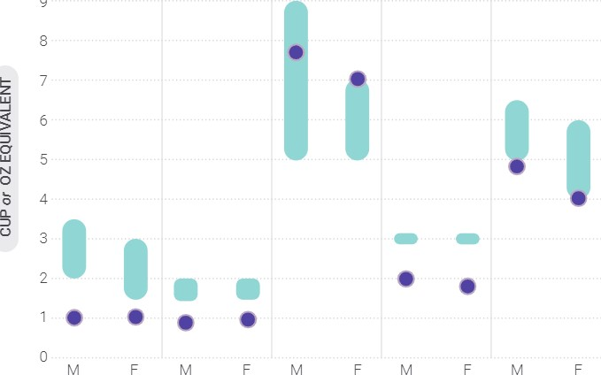8
Total Total Total Total Total Vegetables Fruits Grains Dairy Protein Foods cup eg/day cup eq/day oz eq/day cup eq/day oz eq/day
FOOD GROUPS
Percent Exceeding Limits of Added Sugars, Saturated Fat, and Sodium |  | Exceeding Limit | Within Recommended Limit
Added Sugars | Saturated Fat |  | Sodium
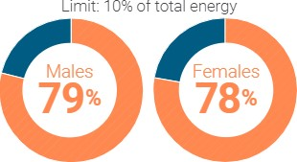
of total energy Limit: of total energy Limit: 1 ,800 mg

oo oo
Average Intakes | Average Intakes  Females | Average Intakes
322 kcal 264 kcal | 259 kcal 229 kcal | 3,451 mg 3,030 mg
Data Sources: Average Intake and HEI-2075 Scores: Analysis of What We Eat in America, NHANES 2015-2016, day 1 dietary intake data, weighted. Recommended Intake Ranges. Healthy U.S.-Style Dietary Patterns (see Appendix 3). Percent Exceeding Limits. What We Eat in America, NHANES 2013-2016, 2 days dietary intake data, weighted.
Figure 3-7
Average Intakes of Subgroups Compared to
Recommended Intake Ranges: Ages 9 Through 13
Recommended Intake Ranges Average Intakes

Vegetables

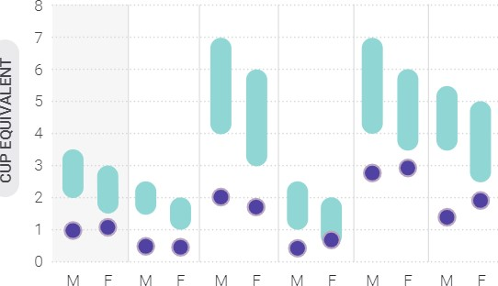
Total Dark- Red & Beans, Starchy Other Vegetables Green Orange Peas, cup eq/day Lentils cup eq/week
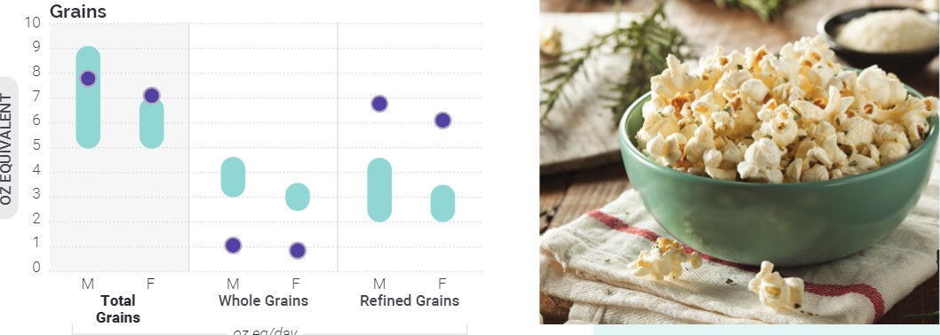
oz
eq/day
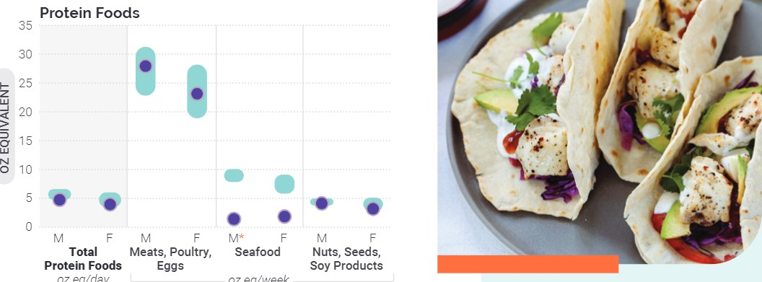
oz
eq/day
oz
eg/week
*NOTE: Estimates may be less precise than others due to small sample size and/or large relative standard error.
Data Sources: Average Intakes: Analysis of What We Eat in America, NHANES 2015-2016, day 1 dietary intake data, weighted. Recommended Intake Ranges: Healthy U.S.-Style Dietary Patterns (see Appendix

Adolescents Ages 14 Through 18
Adolescent females require about 1 ,800 to 2,400 calories per day and males require about 2,000 to 3,200 calories per day.
Table 3-3
Healthy U.S.-Style Dietary Pattern for Adolescents Ages 14 Through 18, With Daily or Weekly Amounts From Food Groups, Subgroups, and Components

  1,800 | 2,000 | 2,200 | 2,400 | 2,600 | 2,800 | 3,000 | 3,200
 | FOOD GROUP OR SUBGROUP^{b} |  |  | Daily Amount of Food From Each Group  (Vegetable and protein foods subgroup amounts are per week.)
 | Vegetables (cup eq/day) | 2% |  | 3 3 3% 4  Vegetable Subgroups in Weekly Amounts | 4
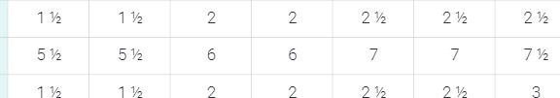
Dark-Green Vegetables (cup eq/wk)
Red and Orange Vegetables (cup eq/wk)
Beans, Peas, Lentils (cup eq/wk)3
Starchy Vegetables (cup eq/wk) | 5 | 5 | 6 | 6 | 7 | 7 | 8 | 8
Other Vegetables (cup eq/wk) 4 4 5 5 5 1/2 7 7
eq/day) | 1 %  6 | 2  6 | 2  7 | 2  8 | 2  9 | 10 | 2%  10 | 10
Fruits (cup eq/day)
Grains (ounce
Whole Grains (ounce eq/day) | 3 | 3 | 4 | 5 | 5 | 5
Refined Grains (ounce eq/day) 3 3 4 5 5 5
Dairy (cup eq/day)
eq/day) | 3 3 3 3 3  ^{l} |  | 3  7 | 3  7 | 3  7
Protein Foods (ounce
 |  |  | Protein Foods Subgroups in Weekly Amounts
Meats, Poultry, Eggs (ounce eq/wk) | 23 | 26 | 28 31 31 33 | 33 | 33
Seafood (ounce eq/wk) 8 10 10 10 10
10
8
140
580
Limit
on
Calories
for
Other
Uses
(kcal/day)
6
51
240 250 320 350 370
Limit on Calories for Other Uses (%/day) 8% 12%  - Calorie level ranges: Females: 1,800-2,400 calories; Males: 2,0003,200 calories. Energy levels are calculated based on reference height (median) and reference weight (healthy) corresponding with a healthy body mass index (BMI). Calorie needs vary based on many factors. The DRI Calculator for Healthcare Professionals, available at nal.usda.gov/ fnic/dri-calculator, can be used to estimate calorie needs based on age, sex, height, weight, activity level.  - Definitions for each food group and subgroup and quantity (i.e., cup or ounce equivalents) are provided in Chapter 1 and are compiled in  Appendix 3_  - All foods are assumed to be in nutrient-dense forms; lean or low-fat; and prepared with minimal added sugars, saturated fat, | refined starches, or sodium. If all food choices to meet food group recommendations are in nutrient-dense forms, a small number of calories remain within the overall limit of the pattern (i.e., limit on calories for other uses). The number of calories depends on the total calorie level of the pattern and the amounts of food from each food group required to meet nutritional goals. Calories up to the specified limit can be used for added sugars and/or saturated fat, orto eat more than the recommended amount of food in a food group.  NOTE: The total dietary pattern should not exceed Dietary Gujdeljnes limits for added sugars and saturated fat; be within the Acceptable Macronutrient Distribution Ranges for protein, carbohydrate, and total fats; and stay within calorie limits. Values are rounded. See Appendix 3 for all calorie levels of the pattern.
Current Intakes
Figure 3-8

Current Intakes: Ages 14 Through 18
Average Daily Food Group Intakes Compared to Recommended Intake Ranges
Recommended Intake Ranges Average Intakes
12
11
10
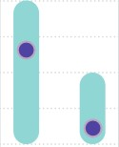
z 8
7 u 6
O
5
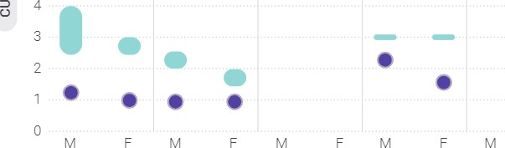
4
Total Total Total Total Total Vegetables Fruits Grains Dairy Protein Foods cup eq/day cup eq/day oz eq/day cup eq/day oz eq/day
FOOD GROUPS
Percent Exceeding Limits of Added Sugars, Saturated Fat, and Sodium
Added Sugars | Saturated Fat
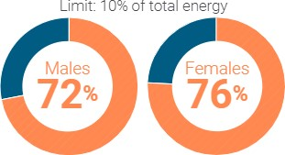
of total energy Limit: of total energy

Of,)
Average Intakes | Average Intakes  Females
347 kcal 277 kcal | 276 kcal 204 kcal
Healthy Eating Index Score
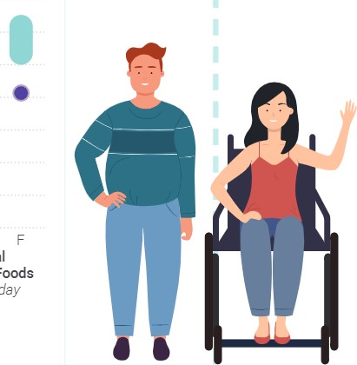
(on a scale of 0-100)
Exceeding Limit Within Recommended Limit
Sodium
Limit: 2,300 mg

OO
Average Intakes
3,888 mg 2,875 mg

Data Sources: Average Intake and HEI-2015 Scores: Analysis of What We Eat in America, NHANES 2015-2016, day 1 dietary intake data, weighted. Recommended Intake Ranges Healthy U.S.-Style Dietary Patterns (see Appendix 3). Percent Exceeding Limits What We Eat in America, NHANES 2013-2016, 2 days dietary intake data, weighted.
Figure 3-9
Average Intakes of Subgroups Compared to
Recommended Intake Ranges: Ages 14 Through 18
Recommended Intake Ranges Average Intakes


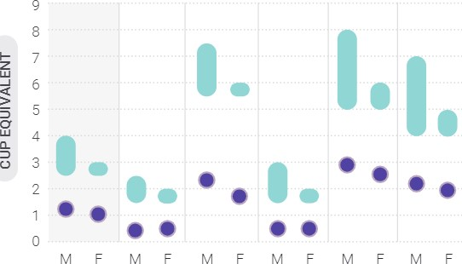
Vegetables
Total Dark- Red & Beans, Starchy Other Vegetables Green Orange Peas, cup eq/day Lentils cup eq/week
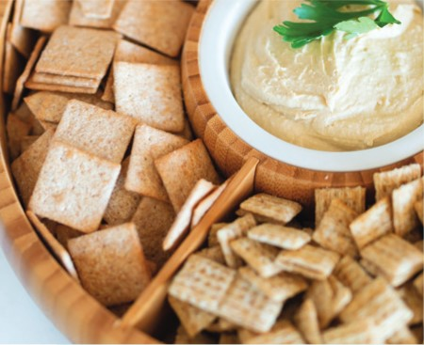
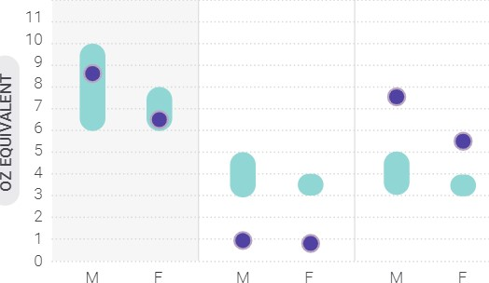
Grains
12
Total Grains Whole Grains Refined Grains
oz eq/day

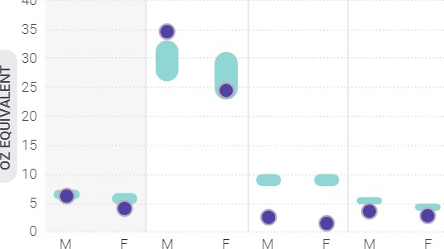
Protein Foods
40
Total Protein Meats, Poultry, Seafood Nuts, Seeds, Foods Eggs Soy Products oz eq/day oz eg/week
Data Sources: Average Intakes: Analysis of What We Eat in America, NHANES 2015-2016, day 1 dietary intake data, weighted. Recommended Intake Ranges:
Healthy U.S.-Style Dietary Patterns (see Appendix 3)

Special
Considerations
The nutrition considerations for the general U.S. population described in Chapter 1 apply to children and adolescents. For example, due to low intakes of food groups as described above, the nutrients of public health concern—calcium, vitamin D, potassium, and dietary fiber—apply to these life stages as well. Although the nutritional needs of youth are remarkably similar to their parents, guardians, and caregivers, these age groups do have some special nutrition considerations. Specifically, increasing intakes of sugar-sweetened beverages and decreasing intakes of dairy are dietary components with notable and concerning shifts in consumption throughout youth. Dietary intake patterns for adolescents, particularly females, also are an area of special consideration.
Accounting for the areas of dietary improvement that are important for all children and adolescents, as well as these special considerations, can improve diet quality during a time when food preferences and intake patterns are formed. When consistently followed, these healthy dietary patterns can provide the foundation for healthy dietary patterns in adulthood, promote health among youth, and help prevent the onset of chronic disease later in life.

Sugar-Sweetened Beverages Sugar-sweetened beverages (e.g., soda, fruit drinks, sports and energy drinks) are not necessary in the child or adolescent diet nor are they a component of the USDA Dietary Patterns. Intake of added sugars increases throughout childhood and adolescence, and sugar-sweetened beverages are a top contributor. As a percent of total daily energy intake, average intake of added sugars is 11 percent among young children and peaks at 1 5 percent during adolescence. Coinciding with this increase is the contribution of sugar-sweetened beverages to total intake of added sugars. In childhood, sugar-sweetened beverages make up about 1 5 to 25 percent of total added sugars intake. By adolescence, their contribution is 32 percent and even higher when considering coffee and tea beverages with added sugars (an additional 7 percent). Most sugar-sweetened beverages (e.g., soda, sports drinks) do not contribute to meeting food group goals and often contain a high number of calories.
Decreasing consumption of sugar-sweetened beverages to reduce added sugars intake will help youth achieve a healthy dietary pattern. Beverages that contain no added sugars should be the primary choice for children and adolescents. These include water and unsweetened fat-free or low-fat milk including low-lactose or lactosefree options or fortified soy beverage—and 100% juice within recommended amounts. Consuming beverages with no added sugars is particularly important for young children ages 2 through 8, when only a small number of calories remains for other uses after meeting food group and nutrient needs with nutrient-dense choices (Table 3-1). The number of calories available for other uses increases slightly as energy needs increase throughout adolescence to support growth and development Tables 3-2 and 3-3). However, most adolescents do not consume foods and beverages in their nutrient-dense forms, meaning they have few or no calories remaining for added sugars.

Juice
Many juice products, such as fruit drinks, contain minimal juice content and are sugar-sweetened beverages because they are primarily composed of water with added The percent of juice in a beverage may be found on the package label, such as "contains 25% juice" or "100% fruit juice." The Nutrition Facts label identifies the amount of sugars in juice products that are not naturally occurring (i.e., added sugars). Although 100% fruit juice without added sugars can be part of a healthy dietary pattern, it is lower in dietary fiber than whole fruit. Dietary fiber is a dietary component of public health concern. With the recognition that fruit should mostly be consumed in whole forms, the amount of fruit juice in the USDA Food Patterns ranges from 4 fluid ounces at the lower calorie levels and no more than 10 fluid ounces at the highest calorie levels.

Dairy and Fortified Soy Alternatives
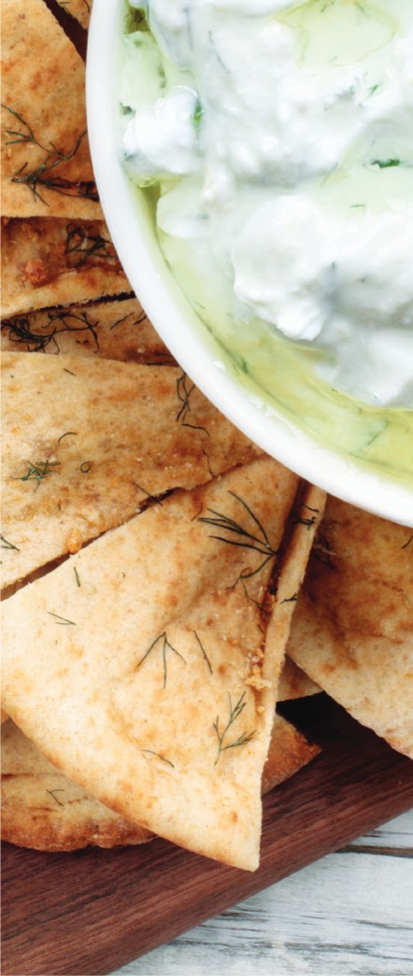
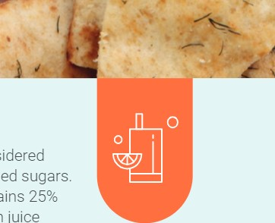
Throughout childhood and adolescence, the types of dairy foods consumed and their contribution to a healthy dietary pattern change. Milk consumption, particularly milk as a beverage, is lower and cheese intake, typically as part of mixed dishes such as sandwiches, pizza, or pasta, is higher among adolescents when compared to younger children. These differences in consumption occur alongside the widening gap between current and recommended intakes of dairy foods that occurs throughout youth. Nutrient-dense options within the dairy group are unsweetened fat-free and low-fat (1 %) milk, yogurt, cheese, fortified soy beverages and yogurt, and low-lactose and lactose-free dairy products. Dairy and fortified soy alternatives provide protein and a variety of nutrients that are underconsumed during these life stages. These include three nutrients of public health concern discussed in Chapter 1: potassium, calcium, and vitamin D. The nutrient composition of dairy foods highlights the importance of adequate consumption. This is especially relevant for calcium and vitamin D, given that adolescents have an increased need for consumption to support the accrual of bone mass.
considered

Adolescent Nutrition
The difference between recommended food group amounts and current intakes is greater for adolescents ages 14 through 18 than for any other age group across the lifespan. As a result, adolescents are at greater risk of dietary inadequacy than are other age groups. For adolescent males and females, low intakes of nutrient-dense foods and beverages within the grains, dairy and alternatives, fruits, and vegetables food groups lead to low intakes of phosphorus, magnesium, and choline. Adolescent females also consume less meat, poultry, and eggs than do adolescent males, and in combination with low consumption of seafood and other protein subgroups, including beans, peas, and lentils, this results in the underconsumption of total protein. In addition, adolescent females have low dietary intakes of iron, folate, vitamin and vitamin BIZ. The potential for nutrient deficiencies existing alongside underconsumption of nutrients of public health concern for all Americans creates a concerning constellation of nutritional risks at a time of rapid growth and development along with the onset of puberty, menarche, and hormonal changes.

Supporting
Healthy Eating
The physical, mental, and emotional changes that occur as children transition from pre-school to school-age and into adolescence come with diverse and changing opportunities to support a healthy dietary pattern. Support and active engagement from the various people and places involved in the lives of children and adolescents is necessary to help establish and maintain healthy dietary patterns that support healthy weight and the prevention of chronic disease.
In early childhood, parents, guardians, and caregivers have a primary role in supporting healthy eating because they control the foods and beverages purchased, prepared, and served. Exposing young children to a variety of nutrient-dense foods within each food group helps build a healthy dietary pattern at an age when taste preferences are acquired. Introducing children to a variety of nutrient-dense foods can be challenging. As children grow, their search for a sense of autonomy and desire for independence often manifest through selective or "picky" eating, food neophobia, or food "jags" (eating only one or a few foods for periods of time). Offering the same type of food to children multiple times, in a variety of forms, or prepared in different ways can increase acceptance and intake of healthy foods within food groups. For example, children may show a dislike for vegetables in the cooked form but accept the raw version. Or, children may only accept fruit when it is cut into small, bite-sized pieces. Even with these strategies, parents, guardians, and caregivers of young children should know it may take up to 8 to 10 exposures before a child will accept a new food.

Children's dietary patterns often resemble those of their household, highlighting the importance of their environment in the establishment of a healthy dietary pattern. Shared meals through shopping, cooking, and consumption provides parents, guardians, and caregivers with an opportunity to model healthy eating behaviors and dietary practices. By making nutrient-dense foods and beverages part of the normal household routine, children can observe and learn healthy behaviors that can extend throughout later life stages.
Ideally, children continue to be exposed to a healthy dietary pattern as they experience changes to their daily routines, such as spending time in child care or school settings. As at home, eating occasions in these settings can be used as opportunities to support a healthy dietary pattern. For example, snacks can be used as a way to promote intake of nutrient-dense fruits and vegetables, like carrot sticks and hummus or apple slices, instead of foods like chips or cookies. Using snacks as an opportunity to encourage nutrient-dense food group choices is especially relevant during early childhood when the total volume of food consumed at regular meals is lower and snacking is common.
When exposed to nutrient-dense foods and beverages at an early age and supported in making healthy choices across environments, a healthy dietary pattern can be established and maintained as children transition to the adolescence life stage. With this transition comes increasing autonomy, increased influence of peers, and decreased influence of parents, guardians, and caregivers on food choice. As a result, foods and beverages are more commonly consumed outside of the home, often with a preference for convenience foods that often are not nutrient-dense. Parents, guardians, and caregivers can continue to support healthy eating during this life stage by providing convenient access to nutrient-dense foods; involving children and adolescents in meal decisions, shopping, and cooking; and guiding adolescents' selection of food purchased and consumed outside the home. In schools and community settings, healthy eating can be encouraged by creating an environment that makes healthy choices the norm.

Page 89 | Dietary Guidelines for Americans, 2020-2025 Chapter 3: Children and Adolescents

Accessing a Healthy Dietary Pattern
Many resources exist to support healthy growth and development during childhood and adolescence. The following Government programs play an essential role in providing access to healthy meals and educational resources to support healthy dietary patterns for all children and adolescents.
- The Supplemental Nutrition Assistance Program (SNAP) provides temporary benefits to families with qualifying incomes for the purchase of foods and beverages. About one-half of all SNAP participants are children. ^{l}
- Households with young children may be eligible for the Special Supplemental Nutrition Program for Women, Infants, and Children (WIC). WIC can help families with limited resources meet their child's nutritional needs by providing nutritious foods to supplement diets. WIC serves children up to the age of 5 years who are at nutritional risk.
- In childcare and afterschool settings, the Child and Adult Care Food Program (CACFP) can support the development of healthy dietary patterns. CACFP is a nutrition program that provides reimbursements for meals and snacks that align with the Dietary Guidelines to eligible children enrolled at childcare centers, daycare homes, and in afterschool programs.
- School-age children can benefit from the National School Lunch Program and School Breakfast Program. The school meal programs can provide nearly two-thirds of daily calories, and therefore play an influential role in the development of a healthy dietary pattern.

- Outside of the school year, the Summer Food Service Program (SFSP) fills the gap by ensuring that children continue to receive nutritious meals when school is not in session. The SFSP operates at sites in a community where children can receive nutritious meals in a safe and supervised environment.
Professionals working with youth and their families can use these, and additional Government and non Government resources that exist at the community, to support healthy eating during these life stages and to establish the foundation for a healthy dietary pattern that will promote health and support disease prevention in later years.
Looking Toward
Chapter 4: Adults
This chapter focused on nutrition issues relevant to children and adolescents. These issues are particularly important because this life stage encompasses significant transitions, from young children who are still dependent on parents, guardians, and caregivers for all their food choices, to adolescents who are highly independent in their food choices. Diet quality tends to decrease as children mature into adolescence, with resulting concerns about underconsumption of nutrients of public health concern. Establishing and maintaining healthy food and beverages choices now can set a firm foundation for healthy dietary patterns that reduce the risk of diet-related chronic disease, an issue of increasing relevance to adults, who are considered in the next chapter.

Source: Characteristics of Supplemental Nutrition Assistance Program Households: Fiscal Year 2018. Available at: www.fns.usda.gov/snap/ characteristics-supplemental-n utrition-ass istance- program-households-fiscal-year-2018_

