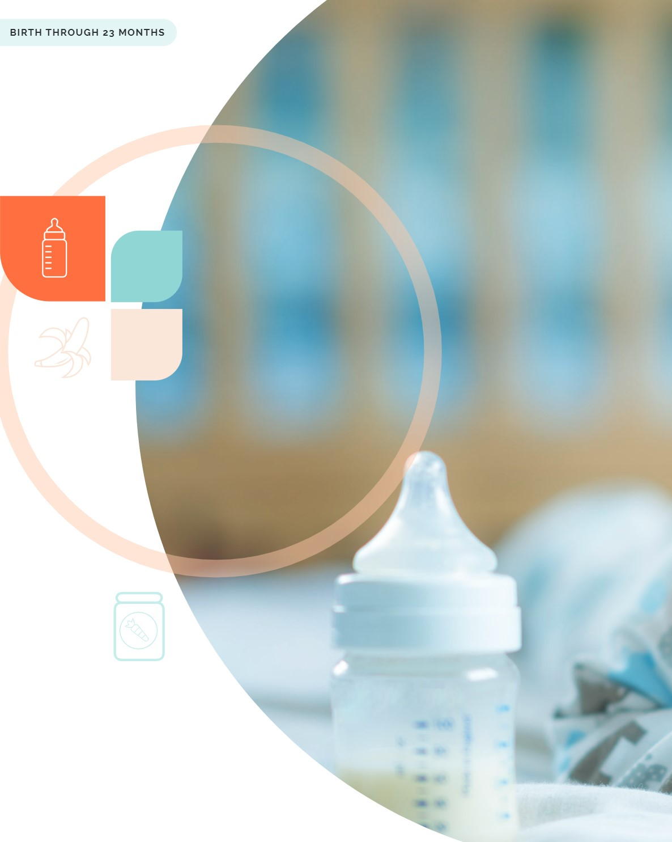
Page 51 | Dietary Guidelines for Americans, 2020-2025 Chapter 2: Infants and Toddlers
CHAPTER

Infants and

Toddlers

Introduction
he time from birth until a child's second birthday is a critically important period for proper growth and development. It also is key for establishing healthy dietary patterns that may influence the trajectory of eating behaviors and health throughout the life course. During this period, nutrients critical for brain development and growth must be provided in adequate amounts. Children in this age group consume small quantities of foods, so it's important to make every bite count!

Key Recommendations

- For about the first 6 months of life, exclusively feed infants human milk. Continue to feed infants human milk through at least the first year of life, and longer if desired. Feed infants iron-fortified infant formula during the first year of life when human milk is unavailable.
- Provide infants with supplemental vitamin D beginning soon after birth.
- At about 6 months, introduce infants to nutrient-dense complementary foods.
- Introduce infants to potentially allergenic foods along with other complementary foods.
- Encourage infants and toddlers to consume a variety of foods from all food groups. Include foods rich in iron and zinc, particularly for infants fed human milk.
- Avoid foods and beverages with added sugars.
- Limit foods and beverages higher in sodium.
- As infants wean from human milk or infant formula, transition to a healthy dietary pattern.
Human milk feeding alone is the ideal form of nutrition from birth through about age 6 months. Human milk provides necessary nutrients, protective factors against disease, and other unique immunological benefits. If human milk is unavailable, infants should be fed an iron fortified commercial infant formula. Once an infant is developmentally ready, foods and beverages should be introduced to complement human milk feeding. These complementary foods and beverages are essential to meet the nutrient requirements of infants starting at about age 6 months and should be selected carefully to help meet these needs. As an infant becomes a toddler, and learns to eat a variety of foods, flavors, and textures, the goal of complementary feeding becomes establishing a healthy dietary pattern and transitioning to a healthy family diet by age 2.
Putting the Key
Recommendations
Into Action

Feed Infants Human Milk for the First 6 Months, If Possible
Exclusive human milk feeding is one of the best ways to start an infant off on the path of lifelong healthy nutrition. Exclusive human milk feeding, commonly referred to as exclusive breastfeeding, refers to an infant consuming only human milk, and not in combination with infant formula and/or complementary foods or beverages (including water), except for medications or vitamin and mineral supplementation.
Human milk can support an infant's nutrient needs for about the first 6 months of life, with the exception of vitamin D and potentially iron. In addition to nutrients, human milk includes bioactive substances and

Donor Human Milk
BIRTH THROUGH 23 MONTHS

immunologic properties that support infant health and growth and development.
U.S. data show that about 84 percent of infants born in 2017 were ever fed human milk, with only 25 percent fed human milk exclusively through age 6 months, and 35 percent continuing to be fed any human milk at age 12 months. Nearly one-quarter of infants were fed some human milk beyond age 1 2 months, with about 1 5 percent of toddlers being fed human milk at age 18 months.
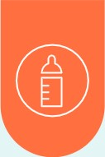
Families may have a number of reasons for not having human milk for their infant. For example, a family may choose not to breastfeed, a child may be adopted, or the mother may be unable to produce a full milk supply or may be unable to pump and store milk safely due to family or workplace pressures. If human milk is unavailable, infants should be fed an iron-fortified commercial infant formula (i.e., labeled "with iron") regulated by the U.S. Food and Drug Administration (FDA), which is based on standards that ensure nutrient content and safety. Infant formulas are designed to meet the nutritional needs of infants and are not needed beyond age 12 months. It is important to take precautions to ensure that expressed human milk and prepared infant formula are handled and stored safely (see "Proper Handling and Storage of Human Milk and Infant Formula").

If families do not have sufficient human milk for their infant but want to feed their infant human milk, they may look for alternative ways to obtain it. It is important for the family to obtain pasteurized donor human milk from a source, such as an accredited human milk bank, that has screened its donors and taken appropriate safety precautions. When human milk is obtained directly from individuals or through the internet, the donor is unlikely to have been screened for infectious diseases, and it is unknown whether the human milk has been collected or stored in a way to reduce possible safety risks to the baby. More information is available at fda.gov/science-research/ pediatrics/use-donor-human-milk.

Proper Handling and Storage of Human Milk and Infant Formula
- Wash hands thoroughly before expressing human milk or preparing to feed human milk or infant formula.
- If expressing human milk, ensure pump parts are thoroughly cleaned before use.
- If preparing powdered infant formula, use a safe water source and follow instructions on the label.
- Refrigerate freshly expressed human milk within 4 hours for up to 4 days. Previously frozen and thawed human milk should be used within 24 hours. Thawed human milk should never be refrozen. Refrigerate prepared infant formula for up to 24 hours.
- Do not use a microwave to warm human milk or infant formula. Warm safely by placing the sealed container of human milk or infant formula in a bowl of warm water or under warm, running tap water.
- Once it has been offered to the infant, use or discard leftovers quickly (within 2 hours for human milk or 1 hour for infant formula).

- Thoroughly wash all infant feeding items, such as bottles and nipples. Consider sanitizing feeding items for infants younger than 3 months of age, infants born prematurely, or infants with a compromised immune system.
More information on storing and handling human milk is available at cdc.gov/ breastfeeding/recommendations/handling_breastmilk.htm. More information on storing and preparing powdered infant formula is available at cdc.gov/ nutrition/downloads/prepare-store-powered-infant-formula-508 .pdf
Additional information on how to clean, sanitize, and store infant feeding items is available at cdc.gov/healthywater/hygiene/healthychildcare/infantfeeding/ cleansanitize.html
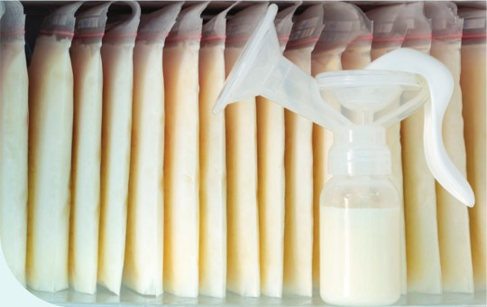
Page 55 | Dietary Guidelines for Americans, 2020-2025 Chapter 2: Infants and Toddlers

Homemade infant formulas and those that are improperly and illegally imported into the United States without mandated FDA review and supervision should not be used. Toddler milks or toddler formulas should not be fed to infants, as they are not designed to meet the nutritional needs of infants.

Provide Infants Supplemental Vitamin D Beginning Soon After Birth
All infants who are fed human milk exclusively or who receive both human milk and infant formula (mixed fed) will need a vitamin D supplement of 400 ICJ per day beginning soon after birth. Infant formula is fortified with vitamin D, thus, when an infant is receiving full feeds of infant formula, vitamin D supplementation is not needed. Families who do not wish to provide a supplement directly to their infant should discuss with a healthcare provider the risks and benefits of maternal high dose supplementation options. Even when consuming a varied diet, achieving adequate vitamin D from foods and beverages (natural sources) alone is challenging, suggesting that young children may need to continue taking a vitamin D supplement after age 12 months. Parents, caregivers, and guardians should consult with a healthcare provider to determine how long supplementation is necessary.

Introduce Infants To Nutrient-Dense Complementary

Foods at About 6 Months Old

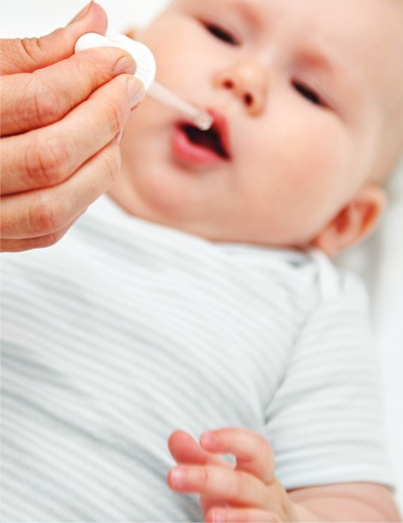
At about age 6 months, infants should be introduced to nutrient-dense, developmentally appropriate foods to complement human milk or infant formula feedings. Some infants may show developmental signs of readiness before age 6 months (see "Developmental Readiness for Beginning to Eat Solid Foods"), but introducing complementary foods before age 4 months is not recommended. Waiting until after age 6 months to introduce foods also is not recommended. Starting around that time, complementary foods are necessary to ensure adequate nutrition and exposure to flavors, textures, and different types of foods. Infants should be given age- and developmentally appropriate foods to help prevent choking. It is important to introduce potentially allergenic foods along with other complementary foods. For infants fed human milk, it is particularly important to include complementary foods that are rich in iron and zinc when starting complementary foods (see Appendix 1 : Nutritional Goals for Age-Sex Groups)
About one-third (32%) of infants in the United States are introduced to complementary foods and beverages before age 4 months, highlighting the importance of providing guidance and support to parents, guardians, and caregivers on the timing of introduction to complementary foods. Early introduction of complementary foods and beverages is higher among infants receiving infant formula (42%) or a combination of infant formula and human milk (32%) than among infants exclusively fed human milk (19%).

Supplemental Vitamin B12 Human milk has sufficient vitamin B12 to meet infant needs unless the mother's vitamin BIZ status is inadequate. This can occur for different reasons, including when the mother eats a strictly vegan diet without any animal source foods. When the mother is at risk of vitamin BIZ deficiency, human milk may not provide sufficient vitamin BIZ. In these cases, the mother and/or infant fed human milk may require a vitamin BIZ supplement. Parents, caregivers, and guardians should consult with a healthcare provider to determine whether supplementation is necessary.

Developmental Readiness for Beginning To
Eat Solid Foods
The age at which infants reach different developmental stages will vary. Typically between age 4 and 6 months, infants develop the gross motor, oral, and fine motor skills necessary to begin to eat complementary foods. As an infant's oral skills develop, the thickness and texture of foods can gradually be varied. Signs that an infant is ready for complementary foods include:
- Being able to control head and neck.
- Sitting up alone or with support.
- Bringing objects to the mouth.
- Trying to grasp small objects, such as toys or food.
- Swallowing food rather than pushing it back out onto the chin.

Infants and young children should be given age- and developmentally appropriate foods to help prevent choking. Foods such as hot dogs, candy, nuts and seeds, raw carrots, grapes, popcorn, and chunks of peanut butter are some of the foods that can be a choking risk for young children. Parents, guardians, and caregivers are encouraged to take steps to decrease choking risks, including:
- Offering foods in the appropriate size, consistency, and shape that will allow an infant or young child to eat and swallow easily.
- Making sure the infant or young child is sitting up in a high chair or other safe, supervised place.
- Ensuring an adult is supervising feeding during mealtimes.
- Not putting infant cereal or other solid foods in an infant's bottle. This could increase the risk of choking and will not make the infant sleep longer.
More information on foods that can present choking hazards is available from USDA at wicworks.fns. usda.gov/resources/reducing-risk-choking-youngchildren-mealtimes.
Page 57 | Dietary Guidelines for Americans, 2020-2025 Chapter 2: Infants and Toddlers

Introduce Infants to Potentially Allergenic Foods Along With Other Complementary Foods
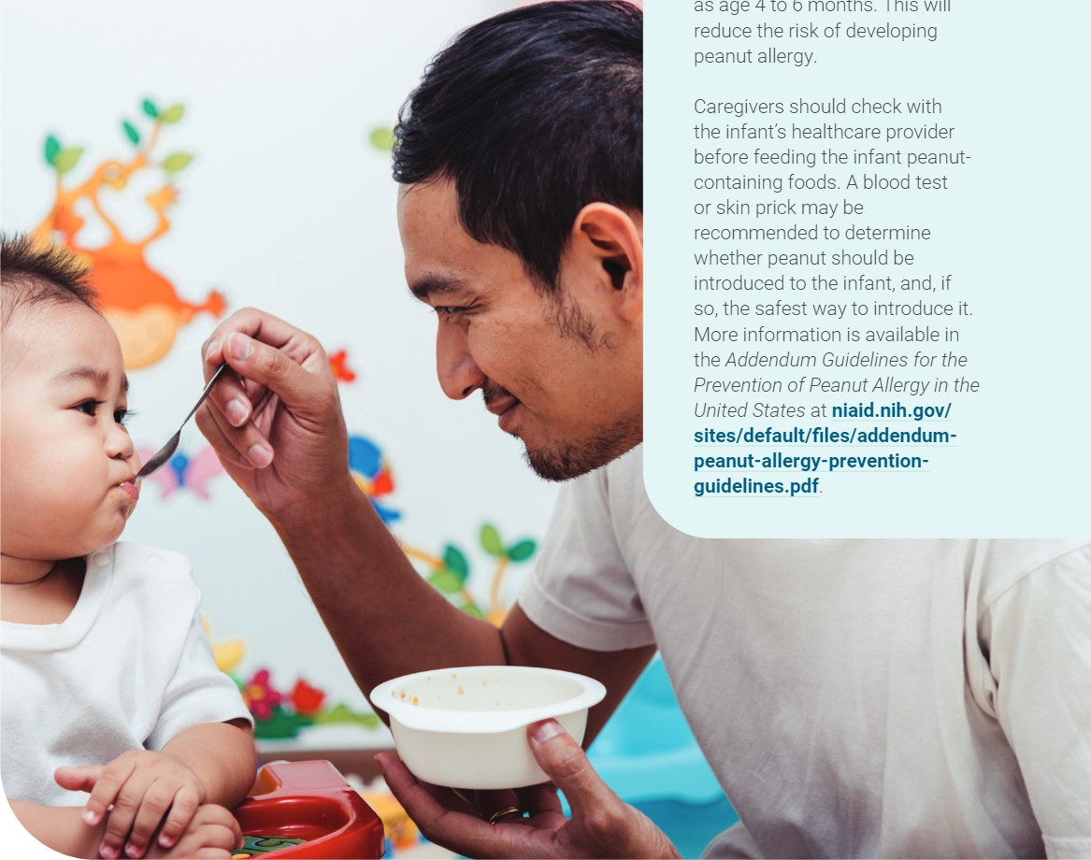
Potentially allergenic foods (e.g., peanuts, egg, cow milk products, tree nuts, wheat, crustacean shellfish, fish, and soy) should be introduced when other complementary foods are introduced to an infant's diet. Introducing peanut-containing foods in the first year reduces the risk that an infant will develop a food allergy to peanuts. Cow milk, as a beverage, should be introduced at age 12 months or later (see "Establish a Healthy Beverage Pattern"). There is no evidence that delaying introduction of allergenic foods, beyond when other complementary foods are introduced, helps to prevent food allergy. For more information, see "For Infants at High Risk of Peanut Allergy, Introduce Peanut-Containing Foods at Age 4 to 6 Months."

For Infants at High Risk of Peanut Allergy, Introduce Peanut-Containing Foods at Age 4 to 6 Months If an infant has severe eczema, egg allergy, or both (conditions that increase the risk of peanut allergy), age-appropriate, peanutcontaining foods should be introduced into the diet as early

as age 4 to 6 months. This will reduce the risk of developing peanut allergy.
Encourage Infants and Toddlers To iron, calcium, potassium, dietary fiber, and vitamin D are Consume a Variety of Complementary available at DietaryGuidelines.gov. Foods and Beverages To Meet Energy and

Nutrient Needs
INTRODUCE IRON-RICH FOODS TO INFANTS
Parents, caregivers, and guardians are encouraged

STARTING AT ABOUT 6 MONTHS OLD
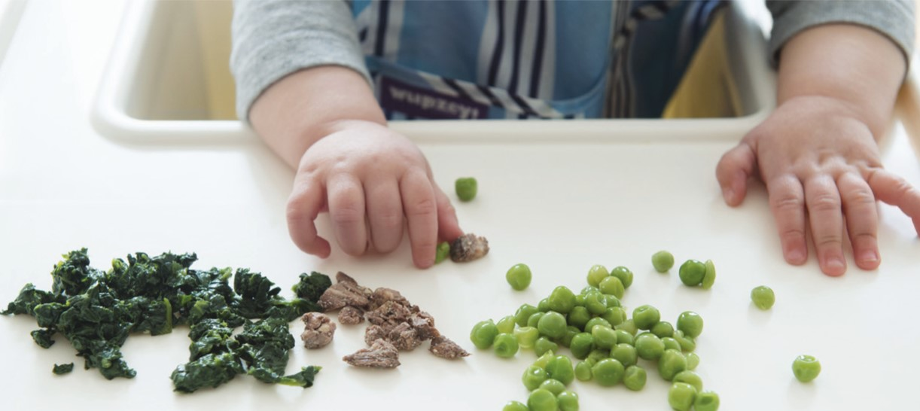
to introduce foods across all the food groups as described below and carrying forward the principles Iron rich foods (e.g., meats and seafood rich in heme in Chapter I—including items that fit within a iron and iron-fortified infant cereals) are important family's preferences, cultural traditions, and budget. components of the infant's diet from age 6 through Complementary foods and beverages should be rich in 11 months to maintain adequate iron status, which nutrients, meet calorie and nutrient requirements during supports neurologic development and immune function. this critical period of growth and development, and Infants are typically born with body stores of iron stay within limits of dietary components such as added adequate for about the first 6 months of life, depending sugars and sodium. Although the Dietary Guidelines does on gestational age, maternal iron status, and timing of not provide a recommended dietary pattern for infants umbilical cord clamping. By age 6 months, however, ages 6 through 1 1 months, infants should be on the infants require an external source of iron apart from path to a healthy dietary pattern that is recommended human milk. for those ages 12 through 23 months (see Appendix 3:
USDA Dietary Pattems). Caregivers of infants exclusively fed human milk should talk with their pediatric care provider about whether In the United States, some dietary components are there may be a need for infants supplementation with of public health concern for infants and toddlers. Iron iron before age 6 months. A complementary food source is a dietary component of public health concern for of iron beginning at about 6 months is particularly underconsumption among older infants ages 6 through important for infants fed human milk because the iron 1 1 months who are fed primarily human milk and content of human milk is low and maternal iron intake consume inadequate iron from complementary foods. during lactation does not increase its content. In the Older infants who are fed primarily human milk also United States, an estimated 77 percent of infants fed underconsume zinc and protein from complementary human milk have inadequate iron intake during the foods, and vitamin D, choline, and potassium are notably second half of infancy, highlighting the importance of underconsumed by all older infants. During the second introducing iron-rich foods starting at age 6 months. year of life, the dietary components of public health concern for underconsumption are vitamin D, calcium, Infants receiving most of their milk feeds as iron dietary fiber, and potassium and for overconsumption fortified infant formula are likely to need less iron from are added sugars and sodium. Lists of dietary sources of complementary foods beginning at 6 months of age. After

age 12 months, children have a lower iron requirement, but good food sources of iron are still needed to maintain adequate iron status and prevent deficiency.

INTRODUCE ZINC-RICH FOODS TO INFANTS STARTING AT ABOUT 6 MONTHS OLD
Zinc-rich complementary foods (e.g., meats, beans, zincfortified infant cereals) are important from age 6 months onwards to support adequate zinc status, which supports growth and immune function. Although the zinc content of human milk is initially high and efficiently absorbed, the concentration declines over the first 6 months of lactation and is not affected by maternal zinc intake. During the second half of infancy, approximately half (54%) of U.S. infants fed human milk have inadequate zinc intake. Prioritizing zinc-rich foods starting at 6 months of age to complement human milk feedings will help infants meet their requirement for zinc.

ENCOURAGE A VARIETY OF FOODS FROM ALL FOOD GROUPS TO INFANTS STARTING AT ABOUT 6 MONTHS OLD
To support nutrient adequacy, foster acceptance of healthy foods, and set intakes on a path toward a healthy pattern, it is important to encourage foods from all food groups. Because very young children are being exposed to new textures and flavors for the first time, it may take up to 8 to 10 exposures for an infant to accept a new type of food. Repeated offering of foods such as fruits and vegetables increases the likelihood of an infant accepting them. A nutrient-dense, diverse diet from age 6 through 23 months of life includes a variety of food sources from each food group.

- Protein foods, including meats, poultry, eggs, seafood, nuts, seeds, and soy products, are important sources of iron, zinc, protein, choline, and long chain polyunsaturated fatty acids. The long-chain polyunsaturated fatty acids, specifically the essential omega-3 and omega-6 fatty acids supplied through seafood, nuts, seeds, and oils, influence the infant's fatty acid status and are among the key nutrients needed for the rapid brain development that occurs through the infant's first 2 years of life. Some types of fish such as salmon and trout are also natural sources of vitamin D. To limit exposure to methylmercury from seafood, the U.S. Food and Drug Administration and the U.S. Environmental Protection Agency issued joint guidance regarding the types of seafood to choose. ¹
- Vegetables and fruits, especially those rich in potassium, vitamin A, and vitamin C, should be offered to infants and toddlers age 6 through 23 months. The vegetable subgroup of beans, peas, and lentils also provides a good source of protein and dietary fiber.
- For dairy, families can introduce yogurt and cheese, including soy-based yogurt, before 12 months. However, infants should not consume cow milk, as a beverage, or fortified soy beverage, before age 12 months as a replacement for human milk or infant formula (see "Cow Milk and Fortified Soy Beverages") In the second year of life, when calcium requirements increase, dairy products, including milk, yogurt, cheese, and fortified soy beverages and soy yogurt provide a good source of calcium. Vitamin D-fortified milk and soy beverages also provide a good source of vitamin D. For those younger than the age of 2, offer dairy products without added sugar (see "Avoid Added Sugars")
- Grains, including iron-fortified infant cereal, play an important role in meeting nutrient needs during this life stage. Infant cereals fortified with iron include oat, barley, multigrain, and rice cereals. Rice cereal fortified with iron is a good source of nutrients for infants, but rice cereal shouldn't be the only type of cereal given to infants. Offering young children whole grains more often than refined grains will increase dietary fiber as well as potassium intake during the second year of life and help young children establish healthy dietary practices.

^{I} CIS. Food and Drug Administration and U.S. Environmental Protection Agency. Advice About Eating Fish. Available at FDA.gov/fishadvice; EPA.gov/fishadvice.

DIETARY COMPONENTS TO LIMIT
While encouraging intake from each food group, some dietary components should be limited.

Avoid Added Sugars
Infants and young children have virtually no room in their diet for added sugars. This is because the nutrient requirements for infants and young children are quite high relative to their size, but the amount of complementary foods they consume is small. Complementary foods need to be nutrient-dense and not contain additional calories from added sugars. In addition, low- and no-calorie sweeteners, which can also be called high-intensity sweeteners, are not recommended for children younger than age 2. Taste preferences are being formed during this time period, and infants and young children may develop preferences for overly sweet foods if introduced to very sweet foods during this timeframe. For more information on added sugars, see Chapter 1.

Avoid Foods Higher in Sodium

Sodium is found in a number of foods, including some salty snacks, commercial toddler foods, and processed meats. In addition to keeping sodium intake within limits for toddlers (see Appendix 1), another reason to avoid high-sodium foods is that taste preferences for salty food may be established early in life. Choose fresh or low sodium frozen foods, when available, and low-sodium canned foods to minimize sodium content. For more information on sodium, see Chapter 1.
Avoid Honey and Unpasteurized Foods and Beverages Infants should not be given any foods containing raw or cooked honey. Honey can contain the Clostridium botulinum organism that could cause serious illness or death among infants. Infants and young children also should not be given any unpasteurized foods or beverages, such as unpasteurized juices, milk, yogurt, or cheeses, as they could contain harmful bacteria.

Establish a Healthy Beverage Pattern
An important part of establishing an overall healthy dietary pattern is careful consideration of beverages. Guidance for different beverage categories is provided below.

WATER
For healthy infants with adequate intake of human milk or infant formula, supplemental water is typically not needed in the first 6 months. Small amounts (up to 4 to 8 ounces per day) of plain, fluoridated drinking water can be given to infants with the introduction of complementary foods. Plain, fluoridated drinking water intake can slowly be increased after age 1 to meet hydration and fluoride needs.

COW MILK AND FORTIFIED SOY BEVERAGES
Infants should not consume cow milk or fortified soy beverages before age 12 months to replace human milk or infant formula. Cow milk does not have the correct amount of nutrients for infants, and its higher protein and mineral content are hard for an infant's kidneys and digestive system to process. Plain cow milk (whole milk) or fortified unsweetened soy beverage can be offered beginning around 12 months of age to help meet calcium, potassium, vitamin D, and protein needs. Flavored milks for children age 12 through 23 months should be avoided because they contain added sugars.

PLANT-BASED MILK ALTERNATIVES
Plant-based milk alternatives, which are sometimes referred to as milk alternatives, include beverages made from plants, such as soy, oat, rice, coconut, and almond. These beverages should not be used in the first year of life to replace human milk or infant formula. They may come in different flavors and some forms have added sugars. Unsweetened versions of these beverages may be accommodated in small amounts in the diet during the second year of life, but most have significantly less protein than cow milk and are not always fortified with calcium and vitamin D. Among plant-based milk alternatives, only fortified soy beverage is currently considered a dairy equivalent. Thus, consuming other plant-based beverages does not contribute to meeting dairy recommendations.

100% FRUIT JUICE

Before age 12 months, 100% fruit or vegetable juices should not be given to infants. In the second year of life, fruit juice is not necessary, and most fruit intake should come from eating whole fruit. If 100% fruit juice is provided, up to 4 ounces per day can fit in a healthy dietary pattern. Juices that contain added sugars should be avoided.

TODDLER MILK AND TODDLER DRINKS
There are no clear needs for toddler milks or drinks. Needed nutrients can be obtained from cow milk or fortified soy beverage and appropriate solid foods. Toddler milks and toddler drinks are drinks supplemented with nutrients, and typically contain added sugars. A variety of nutrient-dense complementary foods and beverages without added sugars should be emphasized for achieving nutrient recommendations.

SUGAR-SWEETENED BEVERAGES
Sugar-sweetened beverages (e.g., regular soda, juice drinks [not 100% fruit juice], sports drinks, and flavored water with sugar) should not be given to children younger than age 2. Drinks labeled as fruit drinks or fruit-flavored drinks are not the same as 100% fruit juice and contain added sugars. These beverages displace nutrient-dense beverages and foods in the diet of young children. Infants and toddlers do not have room in their diets for the additional calories from added sugars found in these beverages. In addition, sugar-sweetened beverage intake in infancy and early childhood may predispose children to consume more of these beverages later in life.

CAFFEINATED BEVERAGES
Concerns exist about potential negative health effects of caffeine for young children, and no safe limits of caffeine have been established for this age group. Caffeine is a stimulant that can occur naturally in foods and beverages or as an additive. Major sources of caffeine for Americans include beverages such as soft drinks, tea, coffee, and sports drinks. Beverages containing caffeine should be avoided for children younger than age 2.
Healthy Dietary
Pattern During a
Toddler's Second Year of Life
In the second year of life, toddlers consume less human milk, and infant formula is not recommended. Calories and nutrients should predominantly be met from a healthy dietary pattern of age-appropriate foods and beverages. The Healthy U.S.-Style Dietary Pattern presented here is intended for toddlers ages 12 through 23 months who no longer consume human milk or infant formula. The pattern represents the types and amounts of foods needed to meet energy and nutrition requirements for this period (Table 2-1). For toddlers who are still consuming human milk (approximately one-third at 12 months and 15 percent at 18 months), a healthy dietary pattern should include a similar combination of nutrient-dense complementary foods and beverages.
Table 2-1 displays the Healthy U.S.-Style Dietary Pattern to illustrate the specific amounts and limits for food groups and other dietary components that make up healthy dietary patterns. The pattern is provided at calorie levels ranging from 700 to 1,000 calories per day, which are appropriate for most toddlers ages 1 2 through 23 months (see Appendix 2. Estimated Calorie Needs). A healthy dietary
Figure 2-1
pattern includes a variety of nutrient-dense fruits, vegetables, grains, protein foods (including lean meats, poultry, eggs, seafood, nuts, and seeds), dairy (including milk, yogurt, and cheese), and oils. Based on FDA and EPA's joint "Advice About Eating Fish," young children should eat seafood lowest in methylmercury, and certain species of seafood should be avoided? If young children are lower in body weight, they should eat less seafood than the amounts in the Healthy U.S.-Style Dietary Pattern. More information is available on the FDA or EPA websites at FDA.gov/fishadvice and EPA.gov/ fishadvice.
After food group and subgroup recommendations are met, a small number of calories are allocated to oils. The recommendation to limit saturated fat to less than 10 percent of calories per day does not apply to those younger than age 2, and the inclusion of higher fat versions of dairy is a notable difference in the pattern for toddlers ages 12 through 23 months compared to patterns for ages 2 and older. However, no calories remain in the pattern for additional saturated fat or for added sugars. To illustrate the concept of nutrient density, Figure 2-1 shows examples of foods and beverages appropriate for this life stage in forms that are not in nutrient-dense forms compared to those that are in nutrient-dense forms. This dietary pattern requires careful choices of foods and beverages but does not require inclusion of fortified products specifically formulated for infants or toddlers to meet nutrient recommendations.

Make Healthy Shifts To Empower Toddlers To Eat Nutrient-Dense Foods in Dietary Patterns
Science shows that early food preferences influence later food choices. Make the first choice the healthiest choices that set the toddlers on a path of making nutrient-dense choices in the years to come. Examples of shifts in common choices to healthier, more nutrient-dense food choices include:
Cereal with Added Cereal with Minimal Fruit Products with Fruit (e.g., canned in Fried Vegetables Roasted Vegetables
Sugars Added Sugars Added Sugars 100% juice)
High-sodium Snacks Vegetables High-sodium Meats Ground Lean Meats Beverages with Added Unsweetened
Sugars Beverages
If consuming up to 2 ounces of seafood per week children should only be fed cooked varieties fram the "Best Choices" list in the FDA'EPA joint "Advice About Eating Fish," available at FDA.gov/fishadvice and EPA.gov/fishadvice_ If consuming up to 3 ounces of seafood per week, children should only be fed cooked varieties from the "Best Choices" list that contain even lower methylmercury: flatfish (eg_, flounder), salmon, tilapia, shrimp, catfish, crab, trout, haddock, oysters, sardines, squid, pallock, anchovies, crawfish, mullet, scallops, whiting, clams, shad, and Atlantic mackerel. If consuming up ta ounces of seafood per week, many commonly consumed varieties of seafood should be avoided because they cannot be consumed at 3 ounces per week by children without the potential of exceeding safe methylmercury limits: examples that should not be consumed include: canned light tuna ar white (albacore) tuna, cad, perch, black sea bass. For a complete list please see: FDA.gov/fishadvice and EPA.gov/fishadvice.
Table 2-1

Healthy U.S.-Style Dietary Pattern for Toddlers Ages 12 Through 23 Months Who Are No Longer Receiving Human Milk or Infant Formula, With Daily or Weekly Amounts From Food Groups, Subgroups, and Components
CALORIE LEVEL OF PATTERNa
700 800 900 1,000
FOOD GROUP OR SUBGROUP ^{b},^{C} Daily Amount of Food From Each Groupd
(Vegetable and protein foods subgroup amounts are per week)
Vegetables (cup eq/day)
Vegetable Subgroups in Weekly Amounts
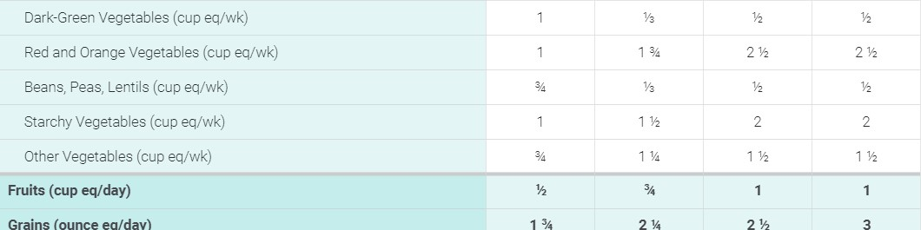
Grains
(ounce
eq/day)
Dairy
(cup
eq/day)
Protein Foods (ounce eq/day) 2 2 2 2
Protein Foods Subgroups in Weekly Amounts
Meats, Poultry (ounce eq/wk) 7 7
Eggs (ounce eq/wk) | 2 |  | 2 1/2 | 2 1/2
Seafood (ounce eq/wk)^{e} | 2-3 | 2-3 | 2-3 | 2-3
Oils (grams/day) 9 9 8 13
- Calorie level ranges: Energy levels are calculated based on median length and body weight reference individuals. Calorie needs vary based on many factors. The DRI Calculator for Healthcare Professionals, available at usda.gov/fnic/dri-calculator, can be used to estimate calorie needs based on age, sex, and weight.
- Definitions for each food group and subgroup and quantity (i.e., cup or ounce equivalents) are provided in Chapter 1 and are compiled in
Appendix 3_
- All foods are assumed to be in nutrient-dense forms and prepared with minimal added sugars, refined starches, or sodium. Foods are also lean or in low-fat forms with the exception of dairy, which includes whole-fat fluid milk, reduced-fat plain yogurts, and reduced-fat cheese. There are no calories available for additional added sugars, saturated fat, or to eat more than the recommended amount of food in a food group.
- In some cases, food subgroup amounts are greatest at the lower calorie levels to help achieve nutrient adequacy when relatively small number of calories are required.
- If consuming up to 2 ounces of seafood per week, children should only be fed cooked varieties from the "Best Choices" list in the FDA/EPAjoint "Advice About Eating Fish," available at FDA.gov/fishadvice and EPA.gov/fishadvice. If consuming up to 3 ounces of seafood per week, children should only be fed cooked varieties from the "Best Choices" list that contain even lower methylmercury: flatfish (e.g., flounder), salmon, tilapia, shrimp, catfish, crab, trout, haddock, oysters, sardines, squid, pollock, anchovies, crawfish, mullet, scallops, whiting, clams, shad, and Atlantic mackerel. If consuming up to 3 ounces of seafood per week, many commonly consumed varieties of seafood should be avoided because they cannot be consumed at 3 ounces per week by children without the potential of exceeding safe methylmercury limits; examples that should not be consumed include: canned light tuna or white (albacore) tuna, cod, perch, black sea bass. For a complete list please see: FDA.gov/fishadvice and EPA.gov/fishadvice.
Current Intakes
Figure 2-2 and 2-3 highlight the dietary intakes of toddlers during the second year of life. Average intakes of the food groups are compared to the range of recommended intakes at the calorie levels most relevant to males and females in this age group (Figure 2-2). Additionally, the average intakes and range of intakes of added sugars, saturated fat, and sodium are displayed. Average intakes compared to recommended intake ranges of the subgroups for grains are represented in daily amounts; subgroups for vegetables and protein foods are represented in weekly amounts (Figure 2-3).
Figure 2-2
Current Intakes: Ages 12 Through 23 Months

Average Daily Food Group Intakes Compared to Recommended Intake Ranges
Recommended Intake Ranges  35 | Average Intakes

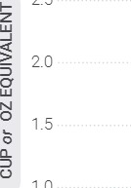

3.0
1.0
25 
0.5
Total Total Total Total Total Vegetables Fruits Grains Dairy Protein Foods cup eq/day cup eq/day oz eg/day cup eq/day oz eg/day
FOOD GROUPS
Average Intakes of Added Sugars, Saturated Fat, and Sodium
Added Sugars Saturated Fat | Sodium
Limit: Avoid Limit: N/A | Limit: 1,200 mg
Average Intakes Average Intakes | Average Intakes
104 kcals 167 kcals | 1,586 mg
Data Sources: Average Intakes: Analysis of What We Eat in America, NHANES 2007-2016, day 1 dietary intake data, weighted. Recommended Intake Ranges: Healthy IJ_S.-StyIe Dietary Patterns (see Appendix 3)

Figure 2-3
Average Intakes of Subgroups Compared to Recommended Intake Ranges: Ages 12 Through 23 Months
O Recommended Intake Ranges Average Intakes

Vegetables
Total | Dark- | Red & Beans, Starchy | Other
Vegetables | Green | Orange Peas,
cup eg/day  Grains |  | Lentils cup eq/week
35
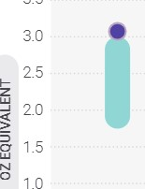
30
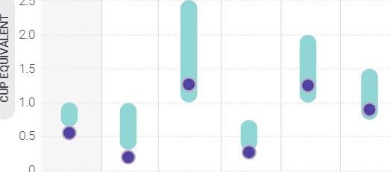
25
05
Total  Grains  Protein Foods  12  10 | Whole Grains |  | Refined Grains
 |  | oz eq/day | Refined Grains
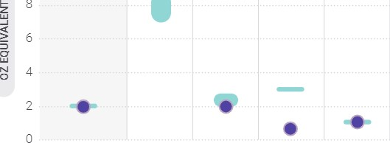
9
Total | Meats, | Eggs Seafood Nuts, Seeds,
Protein Foods | Poultry | Soy Products
oz eq/day |  | oz eq/week
Data Sources: Average Intakes: Analysis of What We Eat in
America, NHANES 2007-2016, day 1 dietary intake data, weighted. Recommended Intake Ranges: Healthy U.S.-Style Dietary Patterns
Approximately 60 percent of toddlers meet or exceed recommended intakes for fruit. A majority of fruit is consumed as whole fruit (fresh, canned, puréed, frozen) or as 100% fruit juice. Average intake of total vegetables is below the range of recommended amounts, with nearly 90 percent of toddlers falling short of recommendations. About one-half of vegetables are consumed on their own, one-quarter are consumed as part of a mixed dish, and nearly 5 percent are consumed as savory snacks (e.g., potato chips).
Total grains, particularly refined grains, are consumed in amounts that exceed recommendations. Conversely, intakes of whole grains fall short of recommended amounts for more than 95 percent of toddlers. A majority of grains are consumed through breads, rolls, tortillas, or other bread products or as part of a mixed dish. Ten percent of grains come from sweet bakery products and approximately 1 5 percent come from crackers and savory snacks. Many of these categories are top sources of sodium or added sugars in this age group.
Average intakes of dairy foods, most of which is consumed as milk, generally exceed recommended amounts in this age group. Intakes of yogurt and cheese account for about 10 percent of dairy intakes. Plant based beverages and flavored milks each make up about 2 percent of dairy intakes among toddlers.
Protein foods intakes fall within recommended range,
on average. Intakes of meats, poultry, and eggs make up a majority of protein foods intakes, however seafood intakes in this age group is low. Children in this age group can reduce sodium intake by eating less cured or processed meats including hot dogs, deli meats, and sausages.
Due to the relatively high nutrient needs of toddlers, a healthy dietary pattern has virtually no room for added sugars. Toddlers consume an average of more than 100 calories from added sugars each day, ranging from 40 to 250 calories a day (about 2.5 to 16 teaspoons). Sugarsweetened beverages, particularly fruit drinks, contribute more than 25 percent of total added sugars intakes and sweet bakery products contribute about 1 5 percent. Other food category sources contribute a smaller proportion of total added sugars on their own, but the wide variety of sources, which include yogurts, ready-to eat cereals, candy, fruits, flavored milk, milk substitutes, baby food products, and breads, points to the need to make careful choices across all foods.

(see Appendix 3


Vegetarian Dietary Pattern During the Second Year of Life
A Healthy Vegetarian Dietary Pattern for young children ages 12 through 23 months who are not fed human milk or infant formula is included in Appendix 3. This pattern describes a lacto-ovo vegetarian diet that includes regular consumption of eggs, dairy products, soy products, and nuts or seeds, in addition to vegetables including beans, peas, and lentils, fruits, grains, and oils. Iron may be of particular concern because plant source foods contain only non-heme iron, which is less bioavailable than is heme iron. Food source lists for both heme and non-heme iron are available at DietaryGuidelines.gov. Vitamin BIZ also may be of concern because it is present only in animal source foods. When feeding infants and toddlers a lacto-ovo vegetarian diet, parents, caregivers, and guardians should consult with a healthcare provider to determine whether supplementation of iron, vitamin BIZ, and/or other nutrients is necessary and if so, appropriate levels to meet their unique needs.
Supporting Healthy Eating
Parents, guardians, and caregivers play an important role in nutrition during this life stage because infants and toddlers are fully reliant on them for their needs. In addition to "what" to feed children, "how" to feed young children also is critical. As noted above, repeated exposure to foods can increase acceptance of new foods. Another important concept is responsive feeding, a feeding style that emphasizes recognizing and responding to the hunger or fullness cues of an infant or young child (see "Responsive Feeding"
Responsive Feeding | Table 2-2
Responsive feeding is a term | Signs a Child is Hungry or Full
used to describe a feeding style that emphasizes recognizing Birth Through Age 5 Months and responding to the hunger or
fullness cues of an infant or young A child may be hungry if he or she: A child may be full if he or she:
child. Responsive feeding helps Puts hands to mouth. Closes mouth.
young children learn how to self- Turns head toward breast or bottle. Turns head away from breast or bottle Puckers, smacks, or licks lips. Relaxes hands. regulate their intake. Has clenched hands.
Age 6 Through 23 Months
See Table 2-2 for some examples of signs a child may show for hunger and fullness when he or she is a newborn through age 5 A child may be hungry if he or she: A child may be full if he or she: months, and signs a child may Reaches for or points to food. Pushes food away.
Opens his or her mouth when offered a Closes his or her mouth when food is
start to show between age 6 spoon or food. offered.
through 23 months. Gets excited when he or she sees food. Turns his or her head away from food.
uses hand motions or makes sounds to Uses hand motions or makes sounds to let you know he or she is still hungry. let you know he or she is still full It is important to listen to the child's hunger and fullness cues to build healthy eating habits during this critical age. If parents, guardians, or caregivers have questions or concerns, a conversation with a healthcare provider will be helpful.
For more information on signs a child is hungry or full, see: cdc.gov/nutritioninfantandtoddlernutrition/mealtime/ signs-your-child-is-hungry-or-full.html. More information on infant development skills, hunger and satiety cues, and typical daily portion sizes is available at wicworks.fns.usda.gov/sites/default/files/media/document/lnfant_Nutrition_ and_Feeding_Guide.pdf.

Accessing a Healthy Dietary Pattern
Many resources exist to support healthy growth and development during infancy and toddlerhood. These include the following Government programs that aim to support a healthy dietary pattern for infants and toddlers living in households with limited incomes:
- The Special Supplemental Nutrition Program for Women, Infants, and Children (WIC) supports infant and early childhood nutrition through supplementing the diets of women who are pregnant or lactating and by providing breastfeeding support and iron-fortified infant formula when human milk is unavailable or fed only partially. WIC accommodates the transition to solid foods by providing nutrient-dense foods in the supplemental food packages offered to older infants and toddlers. Nutrition education and counseling and referrals to healthcare and social services are other important resources offered to income-eligible WIC participants.
- The Child and Adult Care Food Program (CACFP) provides reimbursement for nutrient-dense meals and snacks served to infants and toddlers in participating child care centers, including at Head Start programs, and day care homes where infants and toddlers also have access to health screenings and families can be connected to health services to support their overall well-being.

- The Supplemental Nutrition Assistance Program (SNAP) is the largest food assistance program in the United States. SNAP helps meet the nutritional needs of infants and toddlers living in low income households by providing temporary monthly benefits that can be used to access a healthy dietary pattern.
These Government nutrition programs are especially important for the 14 percentª of families with children who experience food insecurity and may struggle to access the foods needed to support a healthy dietary pattern. Professionals can use these, and additional Government and non-Government resources that exist within communities, to support healthy eating during infancy and toddlerhood.
Looking Toward Chapter 3:
Children and Adolescents
This chapter focused on nutrition issues important to infants and toddlers exclusive human milk feeding, if possible; introducing nutrient-dense complementary foods at about age 6 months; and encouraging infants and toddlers to sample and consume a variety of nutrient-dense foods and beverages to meet their needs. As toddlers grow and their dietary patterns become more integrated with the family's food patterns, new issues arise. These issues, and how to accommodate them within a lifelong healthy dietary pattern, are discussed in the next chapter, which focuses on children and adolescents.
³ More information on food insecurity is available at ers.usda.gov/data-products/ag-andfood-statistics-charting-the-essentials/food-security-and-nutrition-assistance.

